Cub Scout Day Camp 2011
“How To Train A Knight”

Hear Ye, Hear Ye…
Brave young men are sought from all lands to take up the lance, and become a heroic knight. Learn how to train dragons, wield the sword, sing songs of lore, and Scout with the best of them!

To proceed: Please sign ye papers and pay ye fees to start your adventure as a squire. (And don’t worry if your pants get singed by a dragon, we promise to look the other way)
Click here for a map of Emma Long Metro Park.

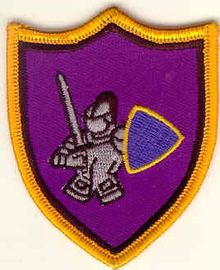
Where:
Emma Long Metro Park, 1600 City Park Rd.
When: June 20 - 24, 2011, 8:30am - 4:30pm

Early Bird Special deadline is May 20th, discounted rate is reflected in price automatically

Cost: $75.00 after May 20th, $100.00

Day Camp is a fun-filled week of adventure for, Cub Scouts from the Tiger through Webelos Scout years. Scouts will enjoy a wide range of theme-based
activities all in a safe, controlled environment.

Don't Forget:
Your Scout will be active at camp, so make sure that he wears his CAMP T-SHIRT everyday with shorts and CLOSED SHOES. No sandals allowed. Other details will be outlined in a parent’s letter sent to you closer to the start of camp.

Camper Health Form: Signature on health form implies all health history information included on your registration form is correct, so far as you know. In the event you are unable to make medical decisions, permission is given to the physician, se-lected by the adult leader in charge, to hospitalize, secure proper anesthesia, or to order an injection or surgery.

Refund Policy: 1) Written refund requests are considered if received in the Council Service Center 10 days prior to the start of the event. 2) Written refund requests submitted after the event will be considered only for personal illness or family emergen-cies. No refund requests will be accepted 10 days following the vent. 3) A service charge of 25% will be assessed on all re-funds. 4) Refund checks will be issued within 30 days of the event’s end. 5) If the event is cancelled or rescheduled by the Council or District, and the participant cannot attend on the new date, full fee will be refunded.

What's Included:
One free camp T-shirt and patch are included in the price. If you desire extra shirts be sure to order them from BSACAC.

Day Camp Volunteers: Day Camps are a 100% volunteer effort. To ensure a successful and safe Day Camp program, volunteers are needed at camp to assist the staff and guide the Cubs through each day’s activities.

Your Pack must provide a minimum of 1 adult volunteer each day for every 4 Cubs attending each camp from your Pack. To help us achieve this ratio we ask for each pack to register as a group versus individually, so that you may coordinate within your pack your adult volunteer ratio and schedules. Adults should register early.

Packs that do not provide enough adult volunteers may be turned away in favor of those that do.Note that youth participant registration may now be completed online, though some paper documentation is still required in that case.

