
CUB SCOUT Pack 90 Father/Son Campout

When? Oct. 9-10, 2010 5 pm – 11 am
(We will be leaving the Scout Jam in the afternoon, in time to set up tents before it gets dark)

Coordinator – Jay Piersall 844-3350 piersall@flash.net
Sign-up & pay thru your den leader or the Pack Website www.pack90austin.org

Den Leaders need to collect the money from each of their families that are going and turn it in to Jay Piersall no later than Sunday October 3rd at 5:00pm. Payment is essential prior to the campout to plan the food needs.
We’ll be organizing the food, and we’ve already reserved the campsites, so it couldn’t be easier: you just show up with your tent.
Where? – Granger Lake Willis Creek Park
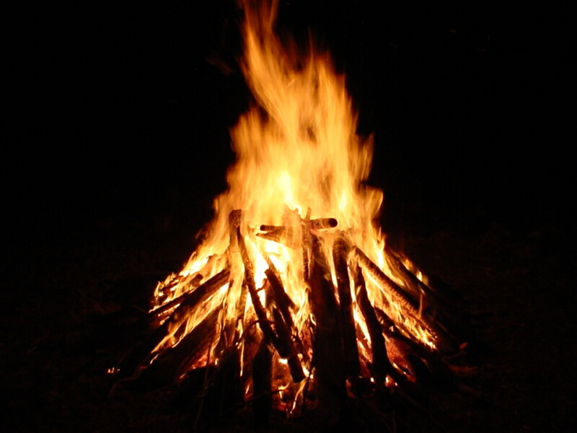

Who can go?
Scouts of all ranks accompanied by a male parent or designated guardian.

Evening Activities

Campfire & skits

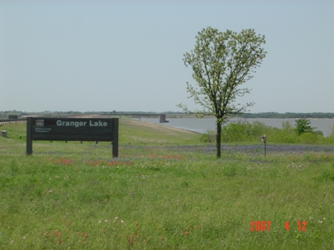

Costs
$12.00 per attendee – This covers the cost of dinner, breakfast, and entrance to the park.

DIRECTIONS
From Interstate 35: Take Highway 95. Go north on Highway 95 to County Road 346. Turn right on County Route 346 and go 4 miles to the park entrance. Follow signs.

Park web site
http://www.swf-wc.usace.army.mil/granger/
Check here for news, maps/directions, general campout information.

Also check our Pack website, http://pack90austin.org, for additional camping guidelines/suggestions.

