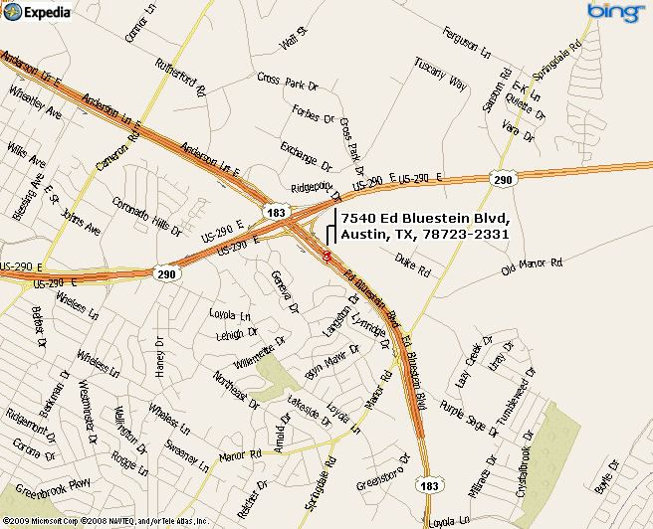

Boy Scouts of America
Scout office and store
7540 Ed Bluestein
Austin, Texas 78723
(512) 926-6363

www.pack90austin.org

