Skills Challenge:
In this arena the boys prove that they can control their bike under a variety of situations. Can they stop straight and safe during an emergency stop? Can they navigate tight turns without falling? Can they ride around obstacles without hitting them and keep control?
The Bike Rodeo Basic Skills Challenge is self guided by Den Leaders or Parent. The purpose of these stations is to help the scout learn the skills needed to control his bicycle. The physical development of the boys in this age range varies widely. These stations may sound simple but performing them can be difficult for the boys. The stations also help them develop their coordination and reflexes.
The instructions for each station are listed below. Please make sure each boy does his best at the stations and does not just rush through them.

Station#1 - Mounting & Dismounting
Course: 2 parallel lines about three (3) feet apart, each 60 Ft. long.
Purpose: To demonstrate starting and stopping while maintaining control of their bike.
Instructions: Put front tire at one end of the lane with bike at a dead stop. Rider must mount their bike and then steer it to the other end without losing balance or swerving out of the lines, and then dismount at the end of the lane. Many boys will have trouble controlling their bike when starting from a complete stop.
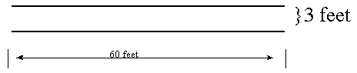

Station#2 - Circling and Changing Direction
Course: A figure 8 course with a 1.5ft lane. Each circle made up of a 12’ft diameter inner circle and 15’ ft diameter outer circle. Enter at one end of the circle 8. Exit can be same end or other end. Mark route with chalk arrows drawn on pavement.
Purpose: To test balance and steering control while changing directions.
Instructions: Rider should start to right and maneuver through the circles in a figure 8. This tests the riders ability to control their bike on simple curved course.
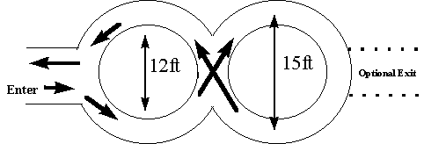

Station#3 - Diminishing Clearance (Straight Line Control)
Course: Two straight lines 60ft long, beginning with 18” width between lines going down to 4” width in the first 30ft. The last 30ft are at the 4” width between the lines. Small cones can be put down every 10 feet or so along the path. Rider can have 20ft before the lines to start, if space is available.
Purpose: To test balance and steering control.
Instructions: Rider starts before lines being and then rides between the lines to the end without crossing the lines. The narrowing of the lines requires the rider to steer straight and forces them to be more controlled in riding.
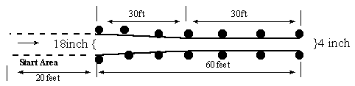

Station#4 - Weaving and Maneuvering
Course: A 40ft course marked about every 8 feet with cones. Mark a starting area before the course for rider to get started. Mark locations of cones with tape or chalk in case they get moved.
Purpose: To test balance, steering control and the riders ability to judge distance.
Instructions: The rider shouldn't hit any obstacles and should weave alternately to the right and left. This tests the balance of the rider and also helps them to control their bike when they need to navigate past road obstacles such as drain grate, trash, or other things found in the road.
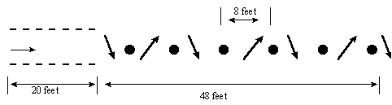

Station#5 - Stopping Ability
Course: Two 60ft lines space 3ft apart. 50ft from the beginning (ten feet from the end), mark a STOPPING line between the two lines. NOTE: The stopping line can be hard for rider to see, a STOP sign placed at the stopping line is a good idea.
Purpose: Test judgment and braking control.
Instructions: Rider should ride through the first 50 feet and be able to bring the bike to a complete stop before touching either foot to the ground within the last 10 feet. Rider starts to brake at first line and tries to stop close to end line. Stop the bike without putting foot to ground. This simulates an emergency stop and helps the rider learn how to control their bike in that situation.
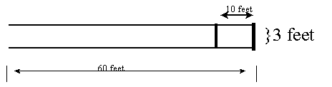

Station#6 - Short Radius Turning
Course: A 3ft wide course that goes straight for 20ft and then turns 180degrees to another straight 20’ section and then turns sharply again into a final 20ft straight section. The straight sections are 4ft apart. (See Diagram). A good way to mark this out is use 3 side-by-side parking spaces. The 3ft riding lane and 4ft space are one space, the next lane and space are another space, then use 3ft of the third space. Now connect with circular line drawn in chalk.
Purpose: To test balance, speed control and steering coordination.
Instructions: Rider should maneuver through the course without veering over the lines or putting a foot down to balance. Once again we are teaching bike control over a curved course that may also confuse the rider.
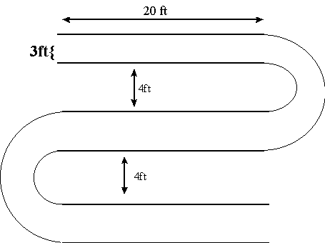

Station#7 – Turtle Crawl (Slow Speed Control)
Course: A 3ft wide straight course that is 60ft long.
Purpose: Rider should maneuver the bike at a slow speed, requiring at least 30 seconds to travel from start to finish.
Instructions: Rider starts and tries to ride to the end under 30 seconds without putting foot to ground or stopping. Rider can begin in runway area. They don't have to start from dead stop at timing line. If a stopwatch is not available have the boys ride as slow as possible. How slow can they go without touching the ground. Ultimate bike control is where it's at.
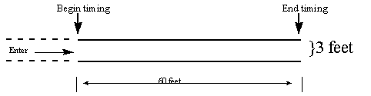

Station#8 – Tight Turns
Course: Four U-shaped bays of diminishing size. Sizes 12’x10’, 12’x8’, 12’x6’, and 12’x4’. Riders start at top of each bay and ride down and around making the turn. If successful they proceed to next smaller bay.
Purpose: To enhance balance and control skills
Instructions: The rider will enter the widest bay first. If they successfully make the turn without putting a foot down or stopping, they move on to the next smaller bay and proceed on until they have gone through all 4 bays.
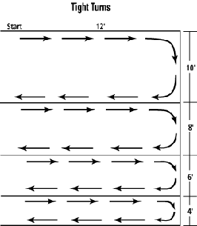

Bike Safety First Challenge:
Here the boys face a series of real life role-playing scenarios. Correct use of hand signals, keeping control of your bike while looking for cars, and learning the rules of the road are important here. Exiting a driveway, watching for cars and controlling your bike, Intersection safety, and proper use of hand signals are all tested here.

Bike Garage:
Here is where safety Checks are performed, boys learn to fix a flat tire, adjust their seat and chain. This is a great station for Webelos to start on their Handyman Activity Pin and Bear Scouts to earn some achievements. Purpose: To learn how to correctly make a repair to your bike. Parents and Leaders may need to assist at the various min-stations.
Mini-Station#A - Tire Repair Achievements:
Webelos Handyman #5 - Fix a flat tire (OR Adjust chain, or seat. DO ONE)
Webelos Handyman #7 - Properly inflate the tires on a bicycle
Instruction:
1. Tire Changing:
Rider removes front tire from a bike. Empty air from tire. Take tire and tube off from rim. Then place tube and tire back on rim and fill with air. Apply tire patch to practice tube.
2. Properly inflate your bike tires.
· Using tire gauge and pump inflate tire to correct pressure
· Look on tire for what correct pressure should be.
Mini-Station#B – Bike Adjustment Achievements:
Webelos Handyman #5 - Adjust chain, or seat (or fix a flat tire. DO ONE)
Webelos Handyman #6 - Properly lubricate Bike Chain
Instruction:
1. Bike Saddle(seat) and Handlebar adjustment
· Learn the proper way to make adjustments.
· Using proper tools adjust the seat
· Learn how to adjust the handlebars.
2. Bike Chain adjustment
· Learn the proper way to adjust your bike chain
· If needed make the proper adjustment.
3. Properly lubricate the bike chain
· Using Teflon Spray, apply to rear hub and spin chain to spread
Mini-Station#C- Air Pressure Check Bear Achievement -14d Tire Repair
Instruction:
1. Apply tire patch to practice tube.
2. Properly inflate your bike tires.
· Using tire gauge and pump inflate tire to correct pressure
· Look on tire for what correct pressure should be.

